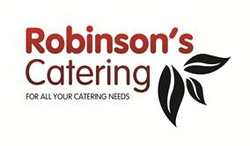

**Breakfast Menu**

* Continental Platter: Sliced Cheeses and Cured Meats, Fresh Fruit

**£13.00**

* Danish Pastries, Croissants, Blueberry Muffins, Bagels

**£2.70 per item**

* Fresh Fruit Salad

**£7.00**

* Greek Yoghurt, Honey & Granola

**£5.00**

* Poached Fruit Compote

**£6.50**

**Hot Selection**

* Bacon or Sausage Sandwiches / Baps **£4.45**